# ASSIGNMENT

NAME: RADHIKA SIDDHAPARA

SUBJECT: SOFTWARE ENGINEERING

MODULE-1

1.WHAT IS SOFTWARE? WHAT IS SOFTWARE ENGINEERING?

---> SOFTWARE IS :

1. Instructions that when executed provide desired features, function and performance.

2. Data structures that enable the programs to effectively manipulate information.

3. Gdescribes the operations and use of the program.

4. Software is a set of programs that allows the user to perform a well-defined function or some specified task.

There are two types of software

1. System software

2. Application software

# 1. SYSTEM SOFTWARE

⦁ Operating System

e.g:- linux,windows etc.

⦁ Language processor and Device driver

e.g:-interpreter, compiler etc.

2. APPLICATION SOFTWARE

⦁ General purpose

e.g:-MS-word, photoshop

⦁ Customised software

e.g:-Railways reservation system etc.

# WHAT IS SOFTWARE ENGINEERING?

Software engineering is the establishment and use of engineering principles in order to obtain economically reliable software and work efficiently on real machines.

Software engineering is the application of a systematic , disciplined , quantifiable approach to the development , operation and maintenance of software; that is the application of engineering to software.

Software engineering encompasses a process , management , technical methods and tools.

2. EXPLAIN TYPES OF SOFTWARE.

There are two types of software.

i. System software

ii. Application software

# ⦁ SYSTEM SOFTWARE

System software refers to a collection of programs that manage and control the computer hardware.

It includes operating system, device drivers , and utility programs.The operating system like Windows or macOS, control the overall operation of the computer and manage resources.

Device drivers allow the operating system to communicate with hardware devices like printers or graphics cards.

Utility programs perform specific tasks like disk cleanup or antivirus scans.System software is essential for the computer to function properly.

# ⦁ APPLICATION SOFTWARE

Application software refers to programs designed to perform specific tasks or provide specific functionality for users.

These are the programs that we interact with directly to accomplish various tasks, such as word processors, web browsers, photo editing software, and video players.

Application software is created to meet the needs and requirements of users,and it can be customized and installed based on individual preferences.

Its what allows us to be productive, creative, and entertained on our computers and mobile devices.

3. WHAT IS SDLC? EXPLAIN EACH PHASE OF SDLC.

The waterfall model is the earliest SDLC approach that was used for software develpoment.

SDLC illustrates the software development process in linear sequential flow. this means that any phase in the development process begins only if the previous phase is complete.

In this model illustrates the software development process begins only if the previous phase is completed. the phases do not overlap.

The sequential phases are:

⦁ REQUIREMENT GATHERING AND ANALYSIS:

All possible requirement of the system to be developed are captured in this phase and documented in a requirement specification document.

# ⦁ SYSTEM DESIGN:

The requirement specification from this phase are studied in this phase and the system design is prepared.this system design helps in specifying hardware and system requirements and helps in defining the .

# ⦁ IMPLEMENTATION:

With inputs from the system design, the system is first developed in small programs called units,which are integrated in the next phase.Each unit is developed and tested for its functionality,which is refered to as unit testing.

# ⦁ INTEGRATION AND TESTING:

All the units developed int the implementation phase are integrated into a system after testing of each unit. post integration the entire system is tested for any faults and failurs.

# ⦁ DEPLOYMENT OF SYSTEM:

Once the functional and non-functional testing is done; the product is deployed in the customer environment or released into the market.

# ⦁ MAINTENANCE:

There are some issues which come up in the client environment. to fix those issues,patches and released. also to enhance the product some better versions are released. maintenance is done to deliver these changes in the customer environment.

4. WHAT IS DFD? CREATE A DFD DIAGRAM ON FLIPKART.

DFD stands for DATA FLOW DIAGRAM and also known as "BUBBLE CHART".

It is a graphical reperesentation of the "flow" of data through an information system, modeling its process aspects.

A DFD is often used as a periliminary step to create an overview of the system, which can later be elaborate.

DFDs can also be used for the visulization of data processing

A DFD shows what kind of information will be input to and output from the system, where the data will come from and go to, and where the data will be stored.

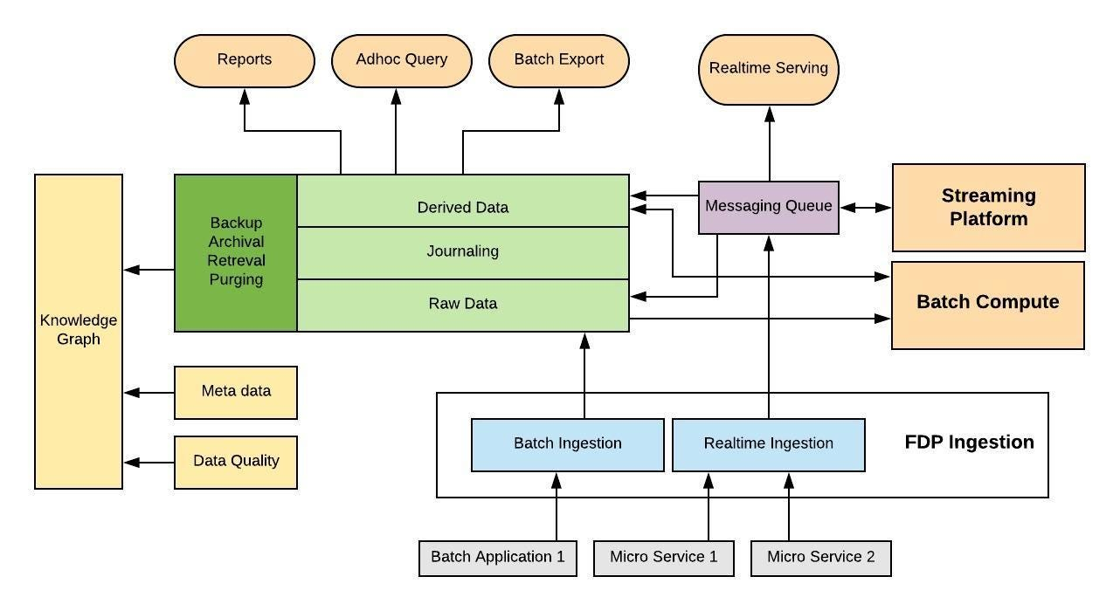

5. WHAT IS FLOWCHART? CREATE A FLOWCHART TO MAKE ADDITION OF TWO NUMBERS.

A flowchart is a visual representation of a process or algorithm using different symbols and arrows.

It helps to understand the flow and sequence of steps in a process .

Its like a roadmap for understanding how something works.

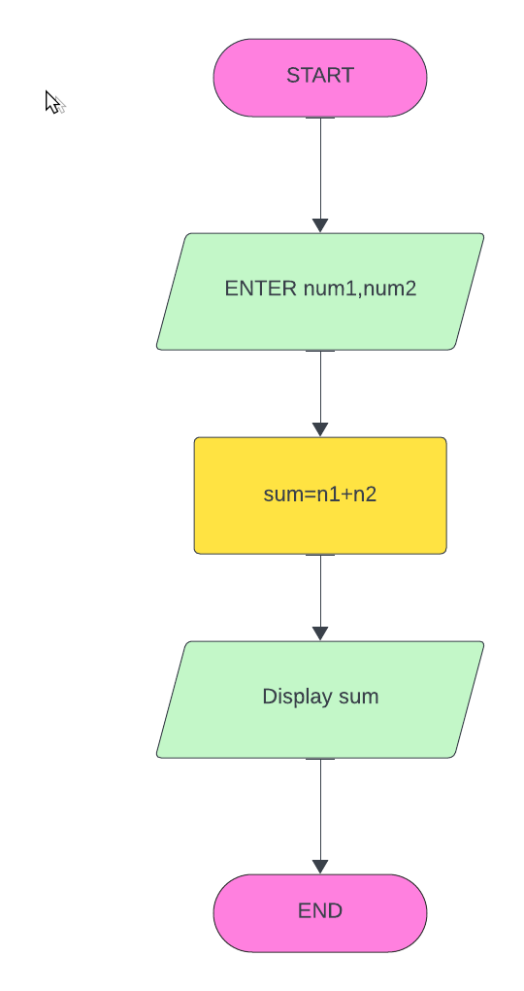

6.WHAT IS USE CASE DIAGRAM?CREATE A USE CASE ON BILL PAYMENT ON PAYMENT.

⦁ It is a dynamic or behaviour diagram in UML.

⦁ It models the functionality of a system using actors and use cases.

⦁ Use cases are aset of actions,services,and function that the system needs to perform.

⦁ In this context, a "system" is something being developed or operated, such as a website.

